Fall 2019 River Research Project:
Variations Among Stream Orders and the Effects of Land Use on Headwater Streams

Carlee Koritkowski
ENV433
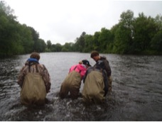
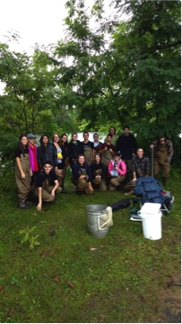
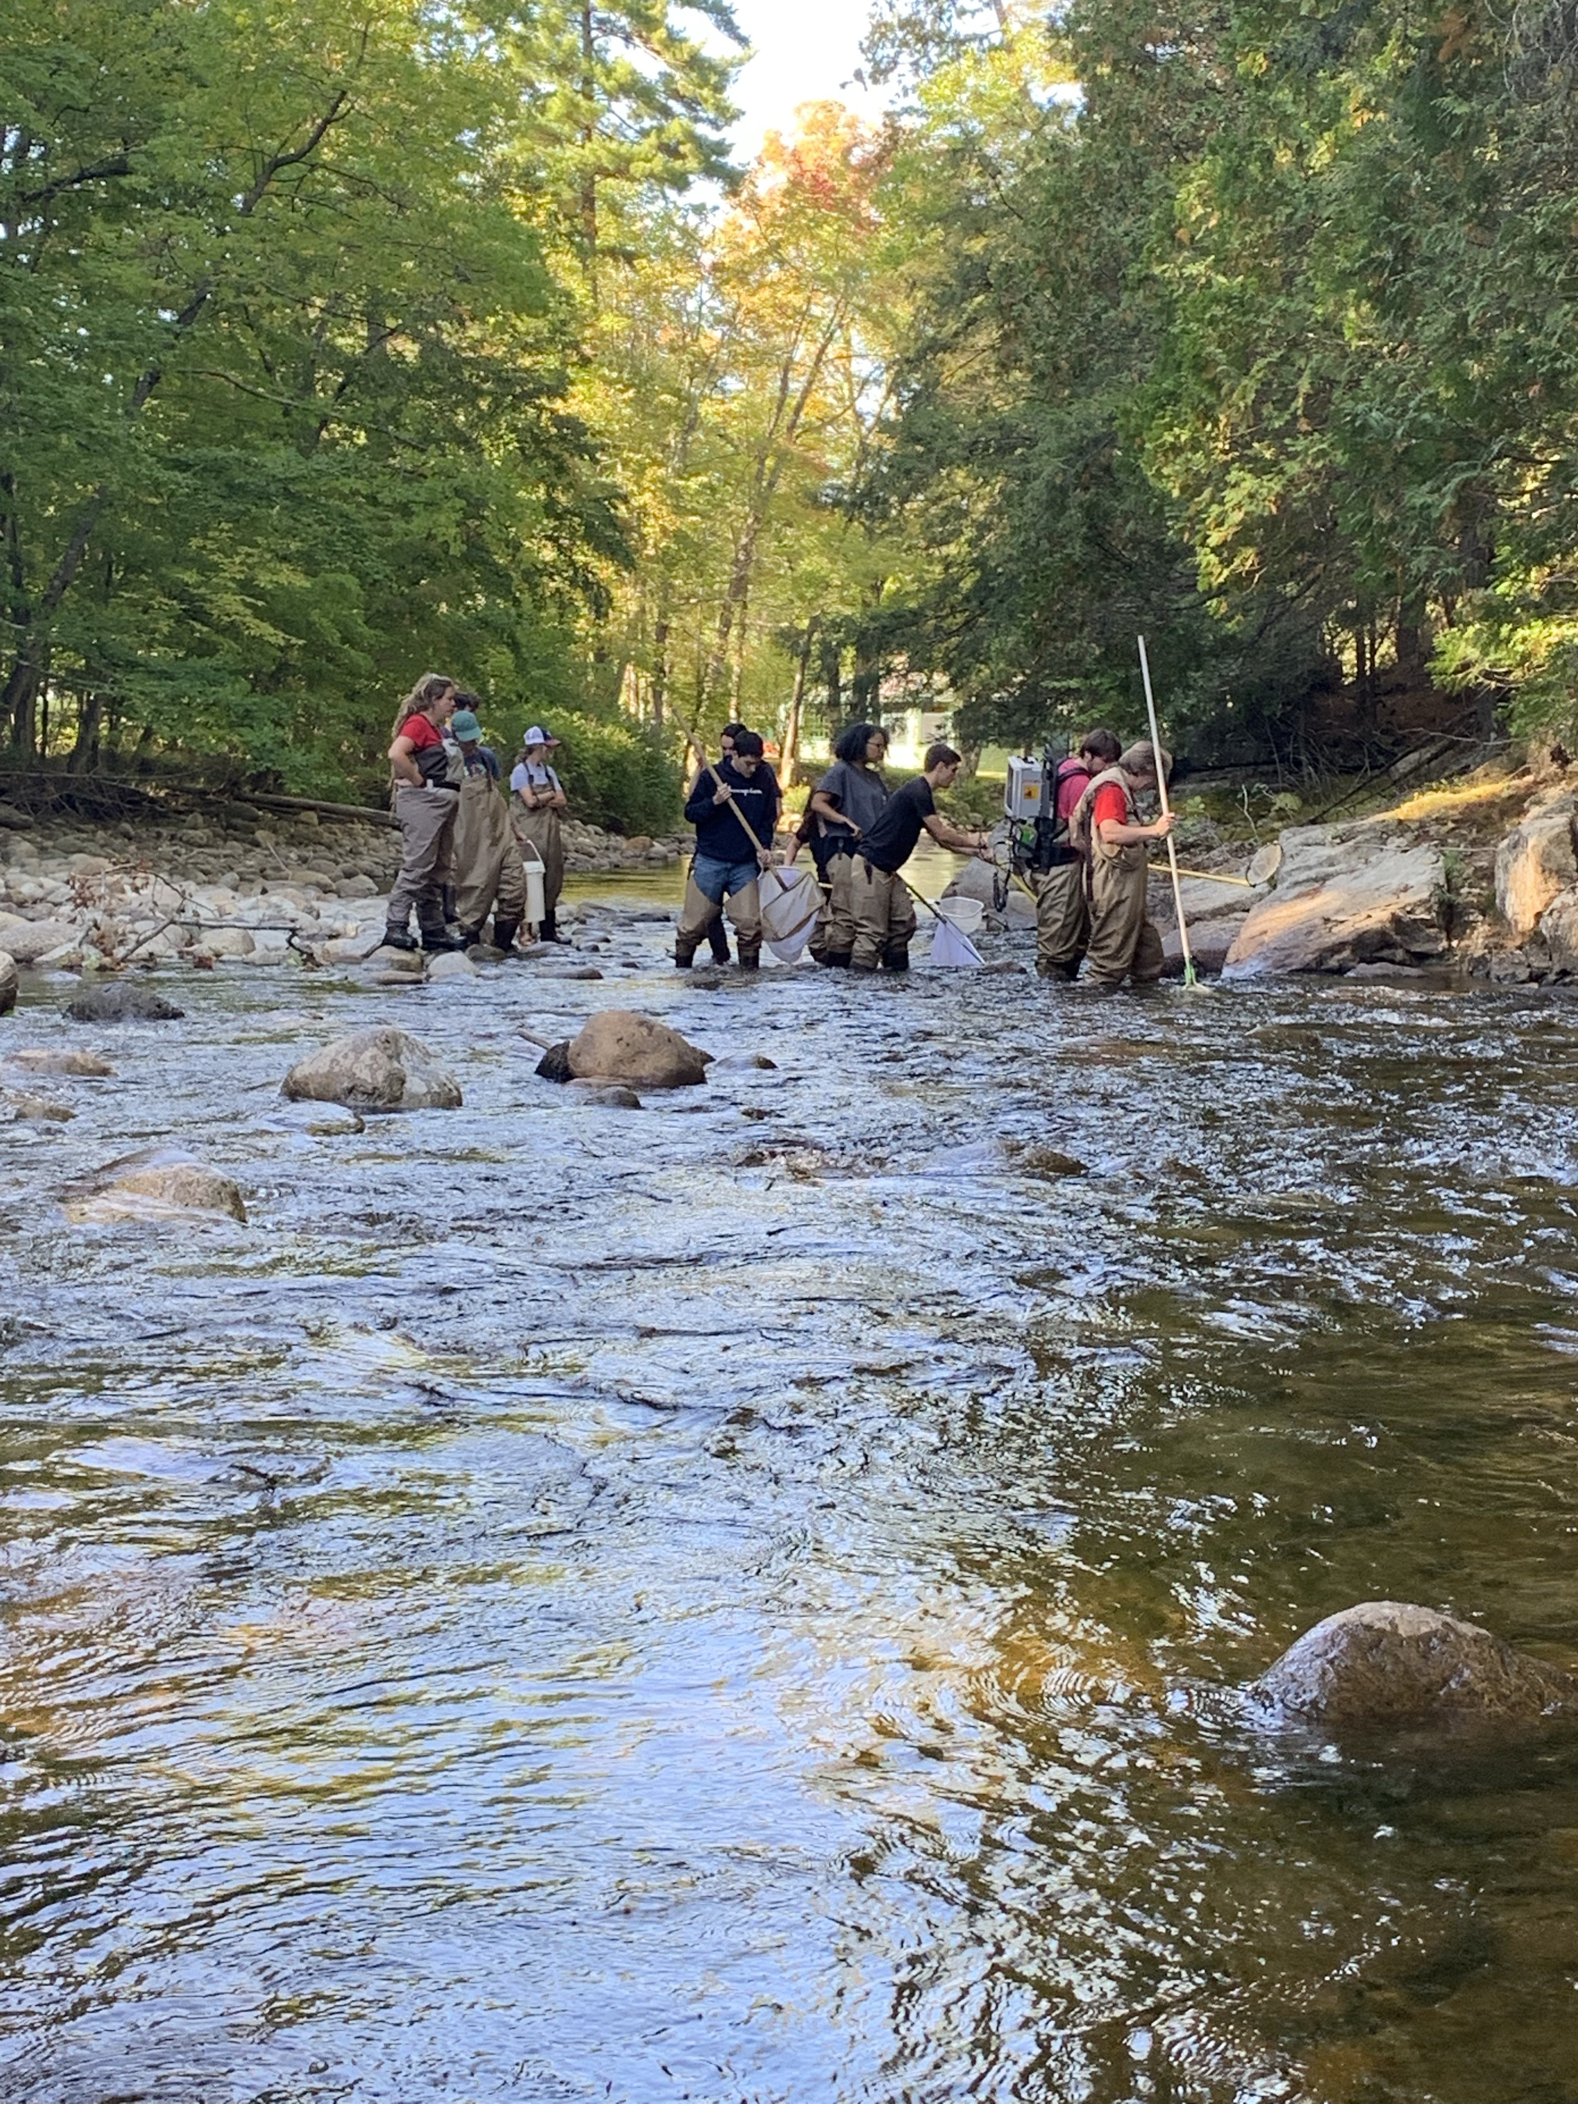
Photos courtesy of Dr. Tim Mihuc
Introduction
Objectives:
River ecosystems are a complex dynamic that change as they flow from headwater to mouth. The differences in environmental factors along a stream gradient create differences in the biotic communities that exist within them. The dynamic relationship between abiotic factors and biota can be a useful tool in assessing the ecosystem and water quality of streams. The predictability of these systems based on baseline principals of stream ecology can be useful in assessing the effects of evolving land use on streams within particular watersheds. The objective of this study is to (1) compare biotic and abiotic factors between stream sizes, and (2) observe the effects of land use on small order streams.

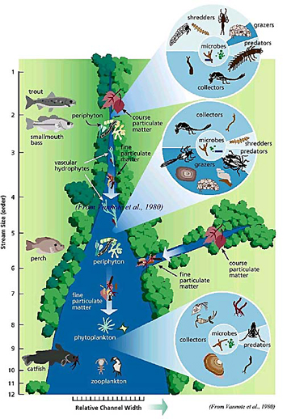
Background:
The River Continuum Concept (RCC), published by Vannote et al. in 1980⁶ provides basic principals of stream ecosystems as they flow from headwater to mouth. First order streams are shallow, have a low velocity, and a small substrate size. These streams are located in areas with dense vegetation cover, and therefore are streams rich in course particulate organic matter (CPOM) and other allochthonous carbon inputs. Periphyton growth is limited in these streams due to the dense canopy cover. Shredders and collectors make up a majority of the invertebrate community, as detrital material is the most readily available source of organic carbon in these streams. Predators and grazers are found in these streams in less abundance. As water flows from headwaters to mid-order streams, the system becomes an intermediate zone. These streams are wider (allowing for more sunlight) with an intermediate depth and velocity, creating ideal conditions for periphyton growth. There is a good mix of CPOM and fine particulate organic matter (FPOM) as CPOM moves downstream. The abundance of periphyton, variety in sources of organic carbon, large number of microhabitats, and moderate levels of disturbance make these streams the most species rich. They are home primarily to grazers and collectors, but suit predators and shredders as well. Moving into large order streams where channel width is wider, but too deep and fast moving for periphyton growth, the primary sources of organic carbon is found in the form of microbiota and FPOM, as well as some macroinvertebrates. Collectors are the most abundant in these streams, however predators can be found in lower abundances (Fig. 1)⁶. Using these baseline principals, scientists can make inferences about abnormalities in stream systems.
Figure 1. Visual representation of the RCC provided by https://stroudcenter.org/continuum/

Today, alteration of land use is a leading contributor to abnormal shifts in stream systems. Agricultural and industrial land use can lead to increased inputs of nitrogen, phosphorous, coliform bacteria, and sediment⁴. Increases in N and P have been correlated to increases in periphyton production², which creates an increase in available organic carbon. Increases in organic carbon and other nutrients can be beneficial to some taxa of aquatic organisms, however others are extremely sensitive to changes in water quality. Aquatic macroinvertebrates are useful indicators of water quality. Unlike fish, their low mobility and high residence time makes them ideal specimen. Pollutant sensitive organisms like some families of Trichoptera, Megaloptera, and Ephemoroptera are less abundant in pollutant-impacted streams. Pollutant tolerant organisms like Oligochaeta and Isopoda will tend to be found in high abundances in streams with poor water quality. Cross-analysis of physical-chemical factors, biotic community surveys, and surrounding land use data allows stream ecologists to assess abnormalities in water quality and provide tactful management plans.

Methods
Study Sites:
We compared five streams ranging in size to compare abiotic and biotic factors along a stream gradient. Four of the streams (Ausable and Whiteface sites) were used to compare effects of land use on water quality.
The Saranac River is a 5th order stream that runs over 200 km². The reach that we sampled was located in Morrisonville, NY and has had minimal changes to the surrounding land use (Fig. 2)
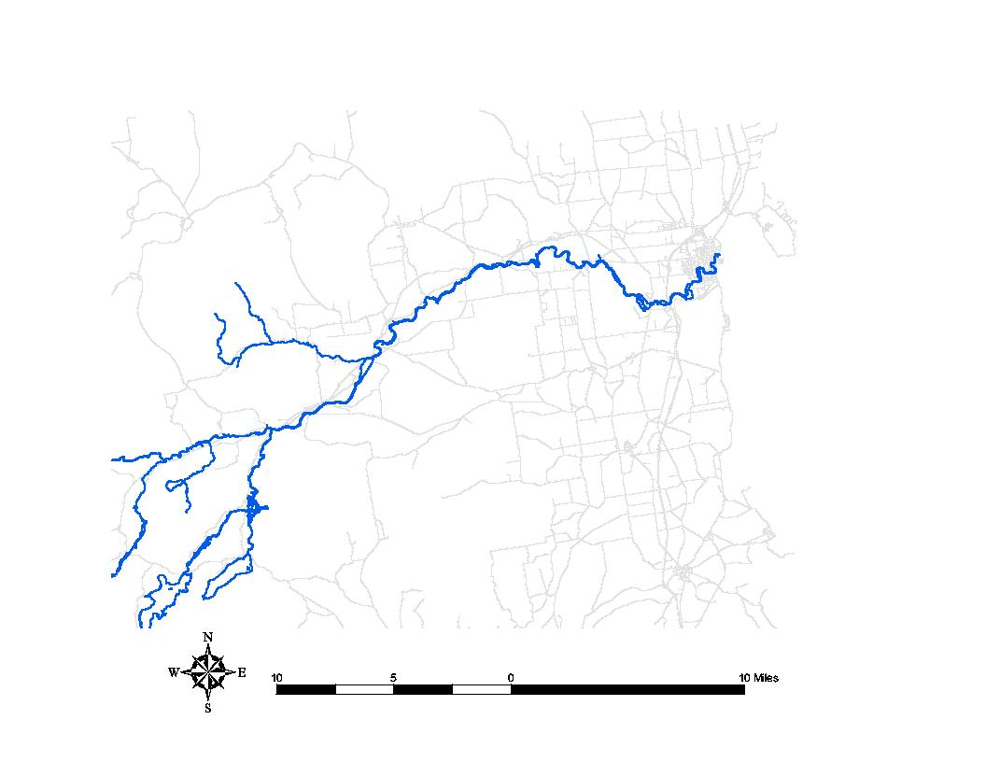

sample site

Figure 2. Map Saranac River reach
Two of the east branches of the Ausable River (Ausable, NY) were sampled as mid-order streams. Ausable Keene was sampled as our reference site to Ausable Jay, a stream impacted by deforestation along the riverbank stream (Fig. 3).

Figure 3. Mid-order streams Ausable Keene (left) and Ausable Jay (right) and their surrounding watershed
Our small order streams were sampled at Whiteface Mountain, NY. White Brook is a well-preserved and densely forested 2nd order headwater stream that was used as a reference in comparison to Ray Brook. Ray Brook is surrounded mostly by land used for agriculture and houses large plots of crops and livestock (Fig 4.)
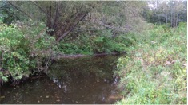
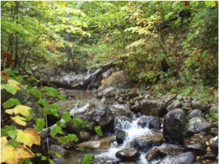

Figure 4. Small order streams White Brook (left) and Ray Brook (right) courtesy or Dr. Tim Mihuc

Data Collection and Analysis:
Physical-chemical samples, benthic invertebrate abundance, periphyton biomass, and fish abundance were measured at each site. The data was transferred and analyzed in Microsoft Excel. Field methods for this project follow Hauer and Lamberti (2007)¹ and are outlined below.

Physical-chemical variables measured in each study stream included stream conductivity, temperature, mean width, mean depth, mean substrate size, mean point velocity and selected hydraulic variables. Variable means were determined from random points selected in a 50-100 m study reach on each stream. In addition organic matter content (CPOM and FPOM) was determined from drift samples and benthic samples. Organic matter biomass was determined after drying each sample at 55C for 24h. For each study site watershed area, link number and stream order were also determined using GIS methods.

Benthic macroinvertebrates were sampled using Surber (or Hess) samples at 5-7 randomly selected locations within a 50m sample reach area. Samples were taken to 10 cm depth in the substrate. Organisms were then preserved using 70% ETOH and placed in labeled container for later identification. Benthic organic matter from each sample was partitioned in to CPOM (>1mm) and FPOM (<1mm) and dried at 55C for 24h for mass determination. Invertebrate samples were identified to lowest possible taxon.

Primary producer biomass was measured using periphyton-epilithon scrapings. Mean size, randomly selected stones were gathered adjacent to each Surber or Hess sample location. Each rock was removed from streambed and an area with a diameter of one inch was isolated using a one-inch diameter cylinder with rubber seal. Isolated area was then scraped with vertically inverted modified toothbrush and rinsed with stream water. The resulting solution was then filtered onto a pre-weighed whatman GF/A paper filter. Biomass was determined after drying each sample at 55C for 24h.

Fish sampling was conducted at each stream utilizing the removal/depletion 3-pass electrofishing method. Each fish sampling reach was approximately 50m in length. Three passes were made up each reach with the same effort. Following each pass the fish were identified, lengthed, and weighed. After the measurements were taken and recorded for all three passes the fish were released into the stream. A cumulative catch vs catch per unit effort (CPUE) curve was used to estimate total abundance.

Results
Abiotic Factors:
The mean channel depths and velocities were directly proportional to stream size. Saranac had the highest mean depth and velocity of 50.84 cm and of 0.77 m/s, respectively. Ray Brook had the lowest at 15.72 cm and 0.12 m/s. Impacted sites and reference sites were similar along the stream gradient for both depth and velocity (Fig. 5).

Figure 5. Mean depth, and velocity at all study sites with standard deviations

Mean Reynolds number, which is the measurement of laminar versus turbulent flow, was directly proportional to stream size. Saranac had the highest value at 281429 and Ray Brook had the lowest value at 11136.4. Impacted sites were slightly (but not significantly) less turbulent than their reference sites (Fig. 6). Mean Froude number, which is the measurement of tranquil versus rough flow, showed slightly smoother flow conditions at the headwater sites. Ausable Jay had the highest Froude number at 0.3730 and White Brook had the lowest at 0.1000. There was no significant difference in Froude numbers between the Saranac and the two Ausable sites (Fig. 7).
Figure 7. Mean Froude Number at all study sites with standard deviations
Figure 6. Mean Reynolds number at all study sites with standard deviations

Biotic Factors:
Periphyton was significantly more abundant in Ray Brook and similarly abundant between all other streams (Fig. 8). Benthic CPOM was most abundant at Ray Brook and least abundant at Ausable Keene. Drift CPOM was most abundant at Ausable Keene and least abundant at Ray Brook (Fig. 9). The Ausable branches had low amounts of both drift and benthic FPOM. The Saranac had the most drift FPOM, but less benthic FPOM than Ray Brook, and more benthic FPOM than White Brook (Fig. 10).

Figure 8. Periphyton biomass at each study site with standard deviations

Figure 9. Mass of course particulate organic matter (CPOM) found in drift and benthic samples at all study sites with standard deviations

Figure 10. Mass of fine particulate organic matter (FPOM) found in drift and benthic samples at all study sites with standard deviations
Overall abundance of invertebrates was highest at Ausable Jay with 1640 specimen and lowest at White Brook with 517. Impacted sites had a higher overall abundance than their reference sites with the difference between the Ausable branches being the most significant (Fig. 11).

Relative species abundance was significantly different between streams along the gradient. The Saranac and the two Ausable sites were mostly Ephemeroptera, Plecoptera, and Trichoptera (EPT), and species diversity was higher in our mid-order streams than in large-order streams. Our results show the highest amount of diversity in the headwater streams. Hydrosychidae dominated Saranac and Ausable. Between the two Ausable sites, there was not a significant difference. White Brook and Ray Brook did have significant differences in their relative species abundances. Ray Brook, our most impacted stream, contained sediment-loving organisms like Oligochaeta, Leptophlebidae, and Chironomidae. Its reference stream, White Brook, had an abundance of Ephemeroptera and Plecoptera (Fig. 10).
Figure 9. Overall abundance of benthic macroinvertebrates at all study sites identified down to family

Figure 10. Relative species abundance at study sites identified down to family

EPT graphs show an abundance of Ephemeroptera at Saranac and Ausable Jay. Ausable Jay had a higher abundance than Ausable Keene. Ray Brook shows abundances of Leptohlebids compared to all other sites (Fig. 11). Plecoptera has the highest abundance in White Brook and was significantly higher than at Ray Brook, which had the lowest abundance (Fig. 11). Trichoptera family composition at all study sites was dominated by filter feeders. The highest density was found at Ausable Jay, and the lowest at Ray Brook (Fig. 11).

Figure 11. EPT family compositions at each study site

Fish composition was highly variable between study sites. Blacknose Dace were abundant in all streams except White Brook. The Saranac was abundant with Shiners, and only Brook Trout were found in White Brook. Sculpin were only found in Ausable Keene, and Fantail Darters were only found in Ausable Jay (Fig. 12).

Figure 12. Fish abundance at each study site

Discussion/Conclusion
Physical data showed results consistent with the principals of the RCC⁶. Mean depth, velocity, Reynold’s number, Froude number, substrate size, and percent embeddedness were relatively consistent with expected trends along the gradient. Mean velocity was more variable at the Ausable sites than other sites, which is likely due to the number of highly variable geography down the gradient of that system. Percent embeddedness was higher at impacted sites than it was at reference sites, which suggests an increased sediment load at impacted sites.
Biological data was also consistent with RCC principals⁶ along the gradient, with some variation in patterns that are consistent with land use studies referenced in this paper^{1,4}. Periphyton biomass was similar for all sites excluding Ray Brook, which had a significantly higher abundance than all other sites. This is likely linked to agricultural nutrient loading from the surrounding watershed. CPOM was most abundant in headwater streams as expected. Ausable Jay had the overall lowest CPOM mass, likely due to the deforestation of the riverbank. FPOM was highest overall in the Saranac, as expected, and our headwater sites. The headwater sites had high benthic FPOM due to the fine sediment contained in their riverbeds. The lack of FPOM at the Ausable sites is correlated to the lack of CPOM associated with that system. Impacted sites had a higher abundance of macroinvertebrates than their reference streams, which is likely due to increased nutrient loading. Relative species abundance was dominated by Hydropsychidae in our mid and large order streams, as expected, due to a positive correlation to drift FPOM abundance. The high species diversity in our mid and low order streams is consistent with principals of the intermediate disturbance theory⁵. Ray Brook had the highest relative species abundance, which can likely be linked to an increased nutrient load from agricultural runoff. Ephemeroptera were most abundant in the Saranac. Ausable Jay had a higher abundance of Ephemeroptera than it’s reference site at Keene, but White Brook had a higher abundance than the impacted site at Ray Brook. This is likely due to increased sediment in Ray Brook, making it more abundant with Leptophlebids, Isopoda, and other sediment-loving organisms. Plecoptera was most abundant in White Brook, which is consistent with community trends of cold headwater streams. The abundance of Plecoptera, a good indicator of water quality, in White Brook compared the significant lack of abundance in Ray Brook indicates the extreme differences in water quality between the two streams. Trichoptera diversity was low in all streams, dominated mostly by Hydrophyschidae. Ray Brook had an extremely low abundance and diversity of Trichoptera, which is likely due to the high sediment embeddedness. Fish abundance and species diversity show patterns consistent with temporal needs of particular species. The abundance of Brook Trout in White Brook is due to the fact that it is a cold-water steam. Ray Brook, which has much less canopy cover, is a warmer stream, indicated by the abundance of Crayfish and Blacknose Dace. Ray Brook also lacks trout, which is another indicator of the poor water quality compared to White Brook.

Conclusion
The River Continuum Concept is a stable baseline concept with useful applications in stream ecology today as supported by our data. In this study, differences in streams of similar sizes is likely correlated to surrounding land use, which was supported by our data, as well as data from previous studies. Future experiments should increase sample size and study period in order to account for environmental and temporal differences. As industrial and agricultural land use continues to expand into our watersheds, more studies like this will be needed in order to examine the inevitable impacts that land use has on stream ecosystems, and help create and implement thoughtful management strategies.

Sources Cited
- F. R. Hauer and G.A. Lamberti. 2007. Methods in Stream Ecology. Academic Press.
- Murdock, Justin & Roelke, Daniel & Gelwick, Frances. (2004). Interactions Between Flow, Periphyton, and Nutrients in a Heavily Impacted Urban Stream: Implications for Stream Restoration Effectiveness. Ecological Engineering. 22. 197-207. 10.1016/j.ecoleng.2004.05.005.
- O’Brien, P.J. & Wehr, J.D. Hydrobiologia (2010) 657: 89. https://doi.org/10.1007/s10750-009-9984-5
- Richardson, Curtis & Flanagan, Neal & Ho, Mengchi & Pahl, James. (2011). Integrated Stream and Wetland Restoration: A Watershed Approach to Improved Water Quality on the Landscape. Ecological Engineering. 37. 25-39. 10.1016/j.ecoleng.2010.09.005.
- Townsend, Colin R., Scarsbrook, Mike R., Dolédec, Sylvain, ( 1997), The intermediate disturbance hypothesis, refugia, and biodiversity in streams, Limnology and Oceanography, 42, doi: 10.4319/lo.1997.42.5.0938.
- Vannote, R.L., Minshall, G.W., Cummins, K.W., Sedell, J.R., & Gushing, C.E. (1980). The River Continuum Concept.

