The Influence of Biodiversity & Community Composition on Plant Productivity

Carlee Koritkowski | ENV332 | May 6, 2020

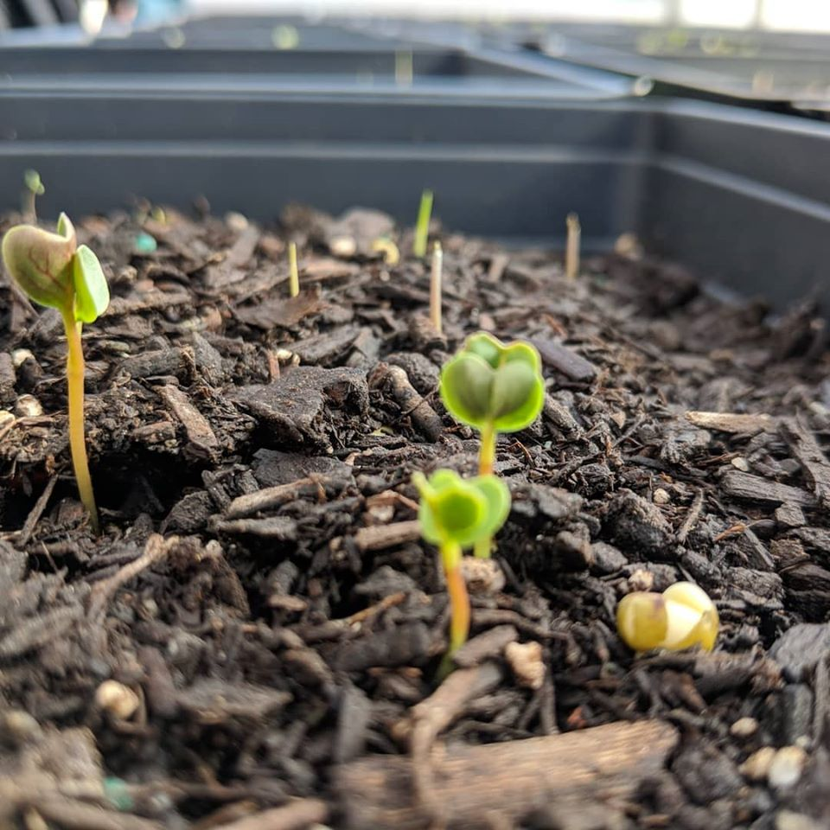
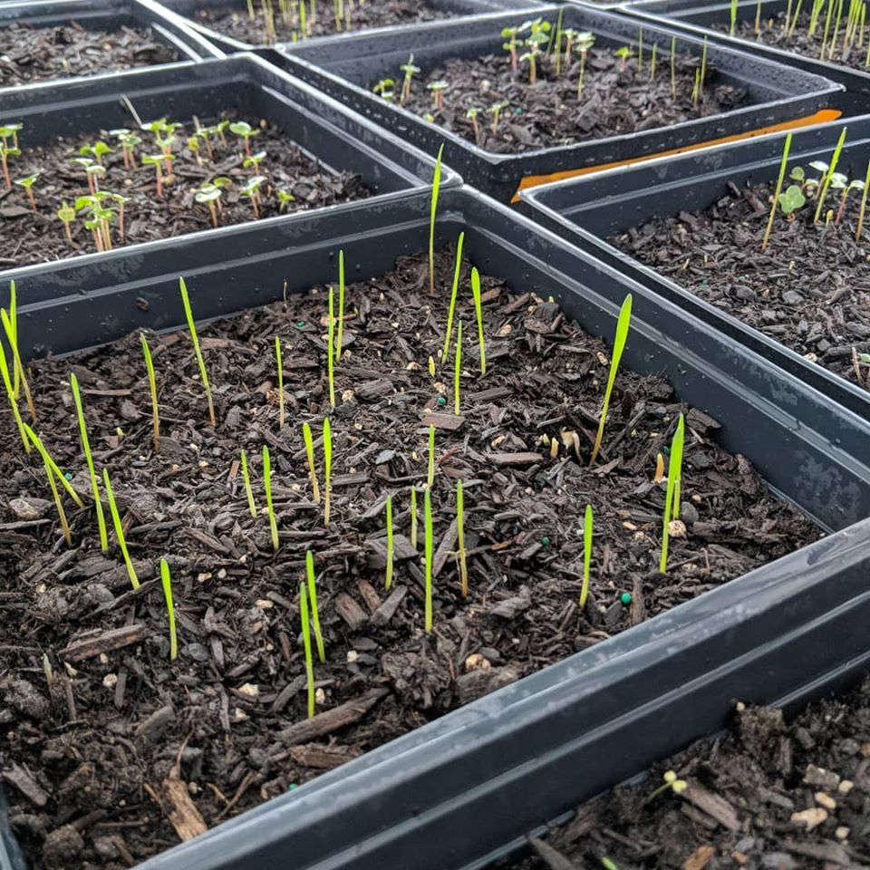

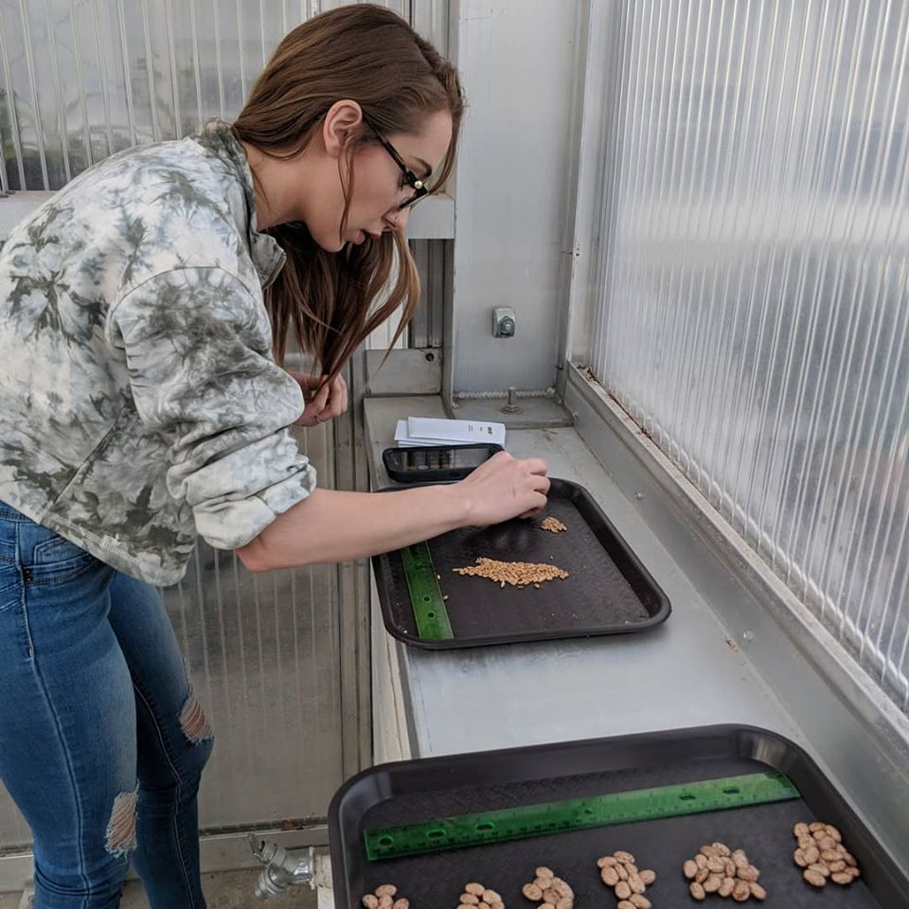

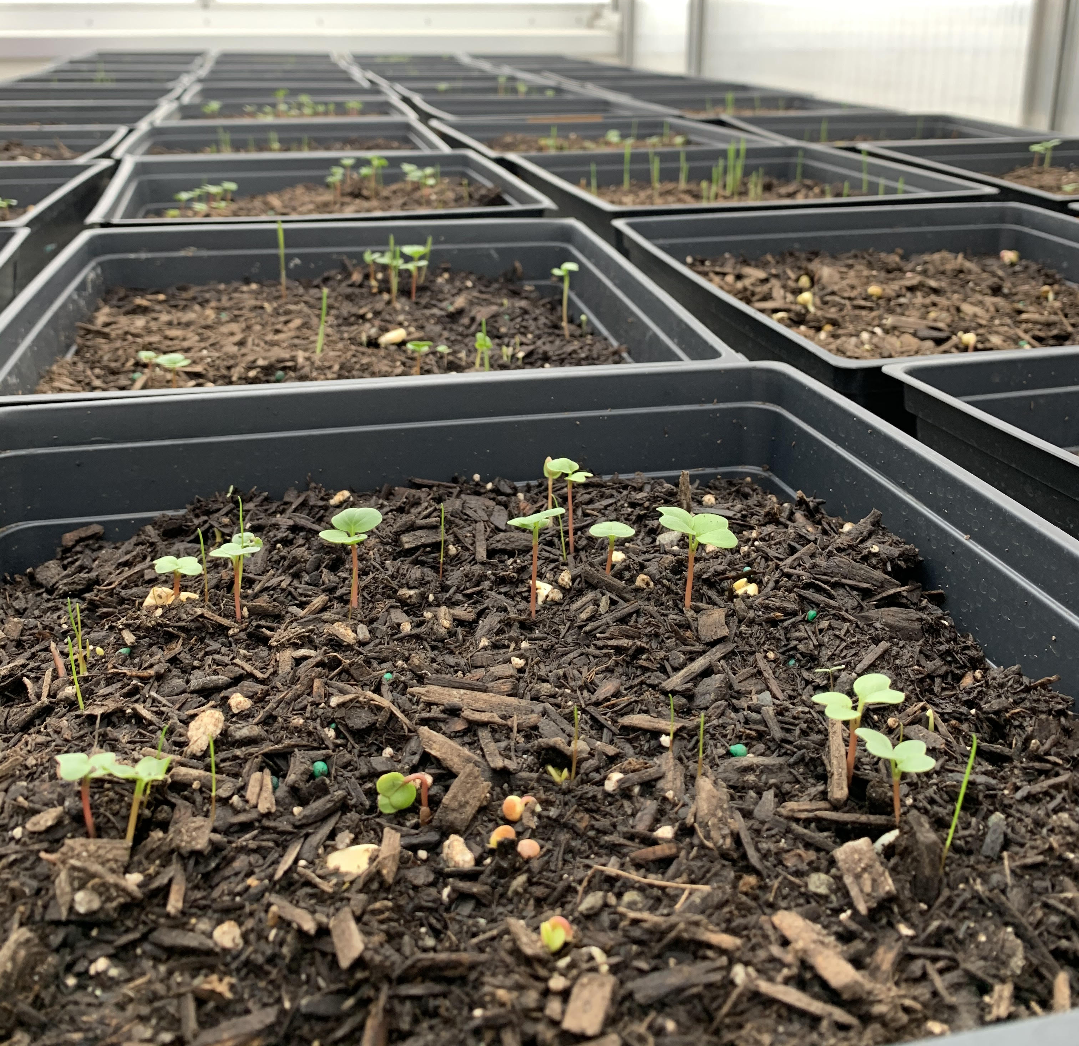

Introduction

The community composition of plants within an ecosystem influences ecosystem processes like the productivity, or photosynthetic capacity of the ecosystem, among others like water retention, and nutrient cycling. Access to light, water, and nutrients within a microhabitat influence the biodiversity, or species richness, of a community (Tilman et al. 1997). Plants have evolved unique ways of responding to competition for resources within their environments. Functional groups are groups of individual species that share similar mechanisms for obtaining resources. Their presence (or absence) can create changes in local ecosystem processes. Functional diversity within a community provides the sustainable partitioning of resources, and allows for increased levels of biodiversity and plant productivity (Tilman, 2001). Research suggests that increased functional diversity maximizes ecosystem function, and provides microhabitats suitable for high levels of biodiversity and production (Silvertown 2004). In this report we examine biomass as a function of biodiversity using species richness and functional group abundance as variables.
Based on niche partitioning, coexistence, and functional diversity concepts communities with higher levels of species and functional diversity should experience increased productivity in the form of aboveground biomass. In order to test this, we planted a number of plots representing varying community compositions over a seven-week period, and measured the aboveground biomass to analyze community productivity.

Methods

Experimental Design: Students created varying sets of community structures with differences in functional group abundance (1-4), and species richness (1, 2, 4 & 8). Functional groups included leafy hearbaceous, grasslike, enlarged taproot, and nitrogen fixing plants. Species present were lettuce (Lactuca sativa), mustard greens (Brassica juncea), cucumber (Cucumis sativus), squash (Cucurbita spp.), corn (Zea mays), wheat grass (Triticum spp.), rye grass (Lolium spp.), carrot (Daucus carota), radish (Raphanus sativus), mung bean (Vigna radiata), kidney bean (Phaseolus vulgaris), and lima bean (Phaseolus lunatus) Corn was present in every tray that included more than one functional group. The treatment options included one species, two species, four species, and eight species with varying functional group abundance (Table 1). Two replicates of each community structure were planted in 26x26 pony flats with standard potting soil and 80 seeds in each flat. Trays were kept in the greenhouse and watered daily for seven weeks and harvested for data collection.

Data Collection: All plots were harvested after seven weeks. Percent soil covered, individual species germinants, total germinants, individual species aboveground biomass, and total aboveground biomass was recorded in excel. Aboveground biomass was measured by clipping individual plants at the base of the stem and recording biomass by species. Species weights were added to obtain total biomass in grams. For this report specifically we focus on aboveground biomass measurements.

Data analysis: Data was analyzed using R-studio. Boxplots and interaction plots were generated in order to analyze productivity in the form of aboveground biomass as a function of community diversity. Total plot biomass was examined, as well as corn and radish biomass individually by plot.

Table 1. Experimental Plot Composition
Student | One Species | Two species | Four species | Eight species
A | 1 functional group:  Corn | 1 functional group:  Corn, Wheat | 4 functional groups:  Corn, Cucumber, Carrot, Kidney Bean | 3 functional groups:  Corn, Wheat, Radish, Carrot, Mustard Greens, Lettuce, Squash, Cucumber
B | 1 functional group:  Lettuce | 1 functional group:  Corn, Rye Grass | 3 functional groups:  Corn, Wheat, Squash, Pinto Bean | 4 functional groups:  Corn, Lettuce, Cucumber, Rye Grass, Carrot, Radish, Pinto Bean, Lima Bean
C | 1 functional group:  Carrot | 2 functional groups:  Corn, Radish | 2 functional groups:  Corn, Rye Grass, Radish, Carrot | 4 functional groups:  Corn, Wheat, Radish, Carrot, Squash, Mustard Greens, Mung Beans, Kidney Beans
D | 1 functional group:  Mung bean | 2 functional groups:  Corn, Mustard Greens | 4 functional groups:  Corn, Mustard Green, Radish, Lima Bean | 4 functional groups:  Corn, Rye Grass, Radish, Carrot, Mung Bean, Pinto Bean, Lettuce, Mustard Greens
E | 1 functional group:  Squash |  | 3 functional groups:  Corn, Squash, Lettuce, Mung Bean  2 functional groups:  Corn, Rye Grass, Cucumber, Mustard Greens | 3 functional groups:  Corn, Wheat, Rye Grass, Lima Bean, Lettuce, Squash, Cucumber, Mustard Greens

Table 1. Community composition of experimental plots. Twenty plot variations in total. Each plot had two replicates for a total of 40 total trays.

Results

Analysis of variance (ANOVA) for total, corn, and radish biomass showed no significant differences in biomass as a function of functional group abundance or species richness. ANOVA tests also showed no significant differences between variables. Figures 1-6 show box plots for aboveground biomass (total, corn, and radish) as a function of functional group abundance, and species richness.

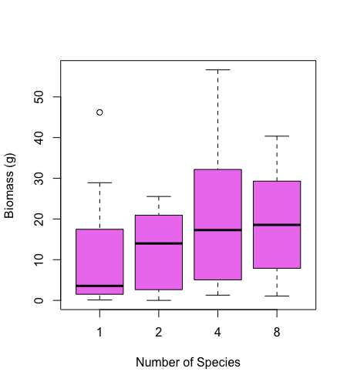
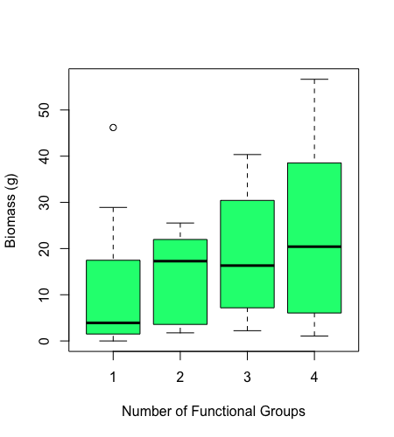

Figure 2. Total aboveground biomass as a function of total number of species present in plots. Biomass is highest in plots with four species present. ANOVA revealed insignificant differences (p= 0.6983)
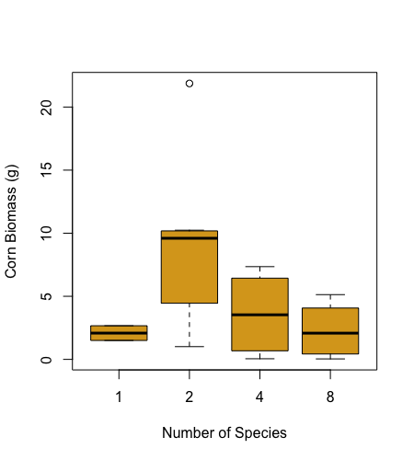
Figure 1. Total aboveground biomass as a function of total number of functional groups present in plots. Biomass is highest as functional groups increase. ANOVA revealed insignificant differences (p= 0.0682)

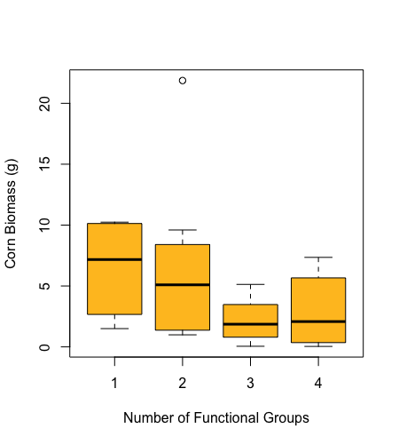

Figure 4. Corn aboveground biomass as a function of total number of species present in plots. Corn biomass was highest when two functional groups were present. ANOVA revealed insignificant differences (p= 0.3176)
Figure 3. Corn aboveground biomass as a function of total number of functional groups present in plots. Corn biomass decreases as functional group presence increases. ANOVA revealed insignificant differences (p= 0.0555)

Figure 6. Radish aboveground biomass as a function of total number of functional groups present in plots. Radish biomass was highest when two functional groups were present. ANOVA revealed insignificant differences (p= 0.7133)
Figure 5. Radish aboveground biomass as a function of total number of functional groups present in plots. Radish biomass was highest when two functional groups were present. ANOVA revealed insignificant differences (p= 0.0722)

Interaction plots showed that overall biomass of our plots were highest when four species from four different functional groups are present. Biomass was also high when eight species were present from three different functional groups. Biomass was lowest in monocultures (Figure 7). Corn individual biomass was highest when eight species were present from three functional groups. However, when only four species were present from three functional groups, biomass was much lower (Figure 8). Radish biomass was highest with four species present from two functional groups, but lowest with four species present from four functional groups, and intermediate when eight species were present from three functional groups (Figure 9).

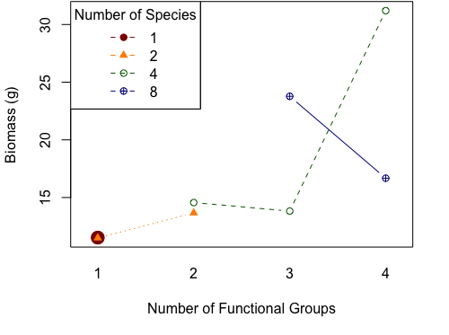

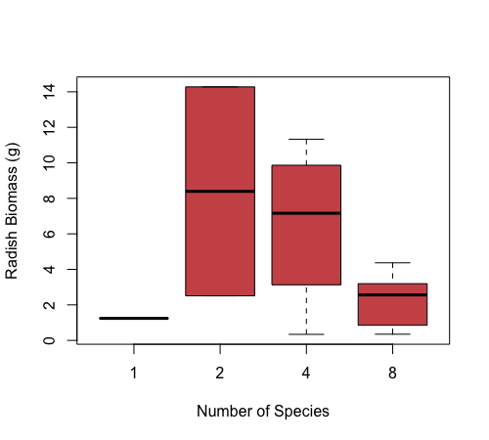
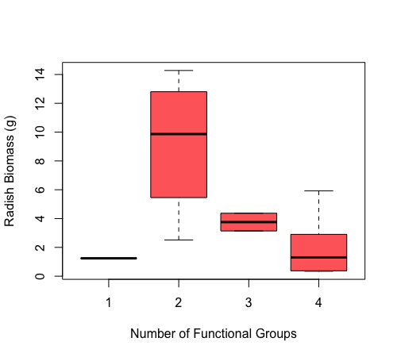
Figure 7. Interaction plot showing the relationship between total biomass, number of species, and number of functional groups present. Biomass is highest when four functional groups and eight species are present, and lowest in monocultures.
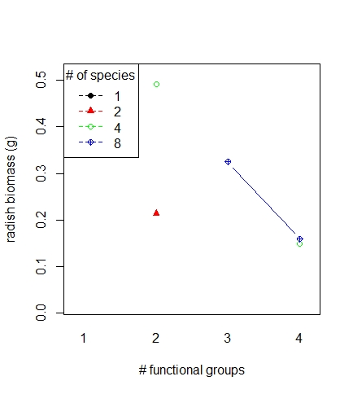
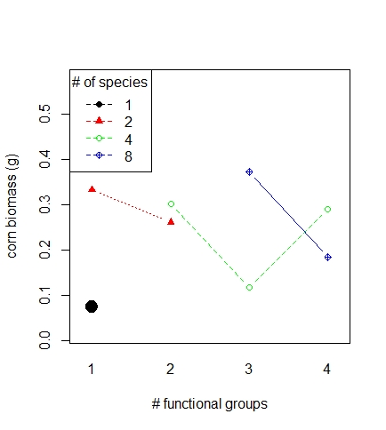

Figure 9. Interaction plot showing the relationship between radish biomass, number of species, and number of functional groups present. Radish biomass is highest when two functional groups and four species are present, and lowest when four functional groups with four species are present.
Figure 8. Interaction plot showing the relationship between corn biomass, number of species, and number of functional groups present. Corn biomass is highest when three functional groups and eight species are present, and lowest in monocultures.

Discussion

Through literary review, we expected to observe significant differences in biomass between monocultures and plots with increased species and functional diversity (Tilman et al., 1997; Tilman, 2001; Silvertown, 2004). While our data does show differences, ANOVA tests conclude those differences were insignificant. This would suggest that in this setting, biomass was not dependent on species or functional diversity within a community. A study published in 2007 concluded that in artificial plant communities, like the ones developed in our research, biomass increased with species richness but increased more significantly with functional diversity (Zhang et al. 2007). However, our data showed no significant difference between the two. The spatial limitations of this study may have contributed to patterns within the data. The trends for total biomass were more consistent with the concepts of functional diversity and coexistence, however corn and radish trends were a bit more complex. This might be contributed to differences in competition variables between specific species within each plot.
Understanding community structure and assemblage patterns can allow for optimization of ecosystem processes and is extremely useful for ecosystem management. Additionally, the knowledge of effects of community structure on agricultural plants can provide maximum yields for food and other commercial use. Lastly, understanding the relationship between community structure and biodiversity can help researchers make predictions about ecosystem responses to disturbance.

Literature Cited:

Silvertown, J. (2004). Plant coexistence and the niche. Trends in Ecology & evolution, 19(11), 605-611.

Tilman, D., Knops, J., Wedin, D., Reich, P., Ritchie, M., & Siemann, E. (1997). The influence of functional diversity and composition on ecosystem processes. Science, 277(5330), 1300-1302.

Tilman, D. (2001). Functional diversity. Encyclopedia of biodiversity, 3(1), 109-120.

Jiang, X. L., Zhang, W. G., & Wang, G. (2007). Effects of different components of diversity on productivity in artificial plant communities. Ecological Research, 22(4), 629-634.

